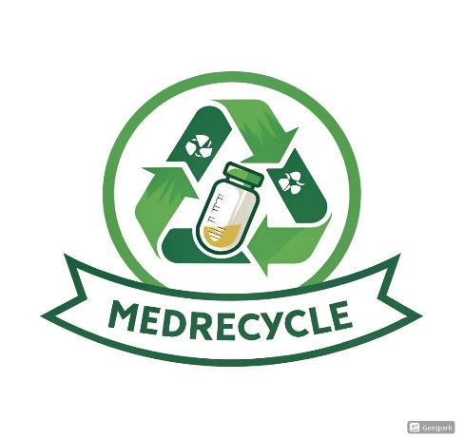
MEDRECYCLE
BUSINESS PLAN

29-04-2025

Muhammad Hassan Khalid (21L-5692)
Muhammad Ahmad (21L-5617)
Muhammad Hamza (21L-5636)
Nimra Amer (21L-5609)

03114000932
hassankhalid768768@gmail.com

Contents
1. Company Description 4
Company History 4
Mission Statement 4
Vision Statement 4
Products 4
Services 5
Potential Customers 5
Points of Differentiation 5
Legal Status and Ownership 5
Key Partnerships 6
Potential Obstacles and their Solutions 6
2. Industry Analysis 7
Threat of New Entrants (Barriers to Entry) 7
Bargaining Power of Suppliers 8
The Bargaining Power of Consumers 9
Threat of Substitute Products or Services 9
Industry Rivalry 10
Challenges to Business Start-Up 10
Competitive Advantage 11
Industry Size, Growth Rate, and Sales Projections 11
Industry Structure 11
Characteristics of Participants 11
Key Success Factors 11
Industry Trends 11
Long-Term Prospects 12
3. Market Analysis 12
Competitor Analysis 14
4. Marketing Plan 15
Marketing Mix 15
5. Product (or Service) Design and Development Plan 19
Development Status 19
Challenges and Risks 19
Projected Development Costs 20
Proprietary Issues 21
6. Management Team and Company Structure 22
Management Team 22
Skills Profile 23
Future Hiring Plan 23
7. Operation Plan 24
Location 24
Facilities Needed 25
Packaging Unit 25
Offices for Operations and Marketing 26
Operational Highlights 26
Production Workflow 26
Logistics 27
Compliance and Safety 27
8. Financial Projections 27
Revenue Drivers 27
Fixed Costs 28
Variable Costs 28
Break-Even Analysis 28
Funding Needs 28
Sales Forecast 29
Cash Flow Statement 30
Income Statement 31
Balance Sheet 32
9. Overall Schedule 33

Company Description

MEDRECYCLE is a start-up built for recycling expired medicines into eco-friendly fertilizers, skincare products, and household cleaning solutions while ensuring safe pharmaceutical waste disposal. The plan is to extract vitamins and minerals from the expired medicine to develop sustainable products and offer waste management services to hospitals and pharmacies. We will generate cash for our business by selling our products, getting pharmaceutical waste management fees and industrial partnerships. The main aim of our business model is to reduce environmental pollution and promote sustainable living through innovative recycling solutions.

Company History
The startup was founded in January 2024 by a team of four. The idea came to life due to the founder’s observation about how expired medicines are a huge cause of pollution. Hence, to avoid the pollution, the team did research and decided to recycle the expired medicines for better use.

Mission Statement
To convert expired medications into beneficial and environmentally friendly items, assist in minimizing pollution, and contribute to a cleaner, healthier world.

Vision Statement
To become the foremost company in safe medicine recycling while developing products that safeguard the environment and enhance life for all.

Products
- Eco-Friendly Fertilizers
- Skincare Products
- Household Cleaning Solutions

Services
- Collection and Sourcing
We will collect expired medicines from trusted suppliers, hospitals and pharmacies.
- Recycling and Manufacturing
We will extract safe pharmaceutical components from expired medicines to produce fertilizers, cosmetics, and cleaning products.
- Quality Control & Safety Testing
We will do rigorous quality assurance testing on each batch of recycled materials to ensure compliance with health, safety and environmental standards.
- Packaging and Distribution
Environmentally friendly packaging and efficient supply chain management.
- Research and Development
We will innovate and improve our products in an in-house R&D lab to identify new applications for expired medicine.

Potential Customers
- Farmers / Green House Owners
- Agricultural Stores
- Hospitals
- Pharmacies
- Cosmetic and Beauty Brands
- Supermarkets and Cleaning Companies

Points of Differentiation
- Safe organic compounds from medicine waste
- Offering products, all made from pharmaceutical and organic resources
- Complete compliance with environmental and health safety laws
- Availability of products in both physical stores and online.
- Participation in pollution reduction and encouraging environmental sustainability, establishing emotional connection with environmentally conscious consumers

Legal Status and Ownership
MEDRECYCLE is yet to be registered as a partnership firm. The partners include Muhammad Hamza, Muhammad Ahmad, Muhammad Hassan Khalid and Nimra Amer.

Key Partnerships
- Hospitals and Pharmacies
- Agricultural Brands
- Retail Chains and Supermarkets
- Logistics and Distribution Companies

Potential Obstacles and their Solutions
- Obstacle: Pharmacies may not give expired medicines easily.
Solution: Signing a contract with them and showing them, the license certificate proving the authorization of our company.

- Obstacle: People might not trust the products made from recycled medicines.
Solution: Raising awareness among the customers by educating them about recycling and showing them licenses or certificates from authorized companies.

- Obstacle: The government might not allow to sell products made from expired medicines.
Solution: Obtaining official licensing by presenting the relevant government authorities with a detailed overview of our process, safely extracting usable components from expired medicines in a strictly regulated environment. Our products are launched only after extensive research and development, rigorous compliance with all applicable regulations and thorough independent testing. By doing so we aim to advance our company's mission of promoting environmental sustainability and public health by responsibly repurposing pharmaceutical waste.

- Obstacle: Competition with strong and well-known brands (skincare,fertlizers,household)
Solution: Describing the recycling process and how the process not only produces fantastic products but also protects the environment from pollution.

Business Model Canvas
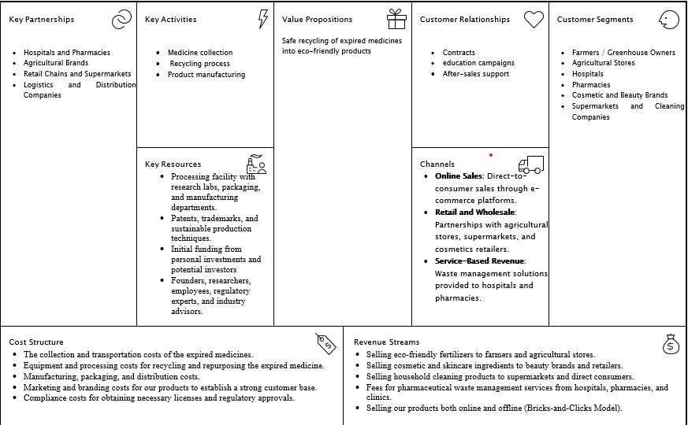

Industry Analysis

Threat of New Entrants (Barriers to Entry)

Industry Challenge
- Regulatory Compliance
Pharmaceutical waste management and recycling industry involves a high level of regulatory compliance and government policies. This is a critical challenge to new entrants in the market.
- High Initial Capital
Opening recycling plants, obtaining licenses, and hiring skilled staff takes enormous sums of money. The need for this capital can deter new players.
- Technology and Expertise
Recycling of expired drugs into useful and safe products requires advanced technology and expertise. Developing a strong brand and reputation takes time.

MEDRECYCLE’s Response
- Strategic Partnerships
Partnerships with large stakeholders such as government agencies, pharmacies, and hospitals can allow for regulatory approval process simplification and create credibility.
- Financial Management
Sound Financial Management by leveraging economies of scale and acquiring finance upfront will reduce costs and allow for growth.
- Technological Innovation
Technological Innovation through ongoing improvement in recycling technology and employment of skilled personnel, MEDRECYCLE will be at the forefront in terms of efficiency and quality.

Bargaining Power of Suppliers

Industry Challenge
- Supplier Influence
Raw material suppliers (pharmaceutical waste and expired drugs) can be influential, particularly if they are limited in number. This can affect recycling material prices and supply chains.

MEDRECYCLE’s Response
- Diversified Supplier Network
Having numerous contracts with different hospitals, clinics, and pharmacies will decrease dependence on a sole supplier and will help minimize risks.
- Long-Term Contracts
Providing long-term relationships and waste disposal services will give a consistent supply and possibly improved pricing.

The Bargaining Power of Consumers

Industry Challenge
- Consumer Pressure
Customer bargaining power (green consumers and companies) can be moderate. Since the market for green products is expanding, customers would demand lower prices or improved quality, affecting profitability.

MEDRECYCLE’s Response
- Unique Value Proposition
Having a portfolio of green, eco-friendly products (cosmetics, fertilizers) and waste management products that nobody else has.
- Brand Loyalty
By building a brand based on sustainability and eco-friendliness, MEDRECYCLE can create customer loyalty and reduce the influence of bargaining power.

Threat of Substitute Products or Services

Industry Challenge
- Alternative Disposal Methods
Alternative pharmaceutical waste disposal methods (incineration, landfill) could be employed instead of recycling.
- Eco-Friendly Rivals
Rivals may come into the market with alternative types of environmentally friendly products (e.g., plant-based cleaning products).

MEDRECYCLE’s Response
- Innovative Recycling Technologies
Developing proprietary recycling technologies to produce new, high-value products will limit the threat of substitutes.
- Focus on Product Diversification
Expansion of the product line to add skincare, fertilizers, and cleaning products gives extra reasons to customers to choose MEDRECYCLE over others.

Industry Rivalry

Industry Challenge
- Market Competition
The industry can experience medium to high competition from other firms venturing into the green product industry and pharmaceutical waste management. Nevertheless, since this is a niche industry, competition can be restricted at the beginning.

MEDRECYCLE’s Response
- Brand Differentiation
By being an environmental brand that offers both product innovation and recycling, MEDRECYCLE can create a strong, distinctive market image.
- Strategic Partnerships
Alliances with hospitals, government agencies, and environmental organizations could give MEDRECYCLE a competitive edge and special market access.

Challenges to Business Start-Up

- Challenge: The pharmaceutical recycling industry is highly regulated. Obtaining licenses required for the industry, environmental accreditation, and health safety clearance can be slow and complex.
Strategy: Use legal experts, maintain good relations with regulatory bodies, and adhere to regulations from the beginning in order to overcome such hurdles efficiently.

- Challenge: Starting capital required to establish recycling equipment, research, and development, and employing qualified personnel may be high.
Strategy: Pursue investment from venture capitalists or angel investors who demonstrate a strong commitment to environmentally sustainable enterprises. Moreover, seeking government grants dedicated to sustainability initiatives may alleviate fiscal pressures.

- Challenge: Offering the knowledge and implementation of environmentally friendly recycling processes for pharmaceutical residues to consumers, pharmacies, and hospitals is challenging.
Strategy: Raise awareness among the general public and companies about the environmental advantages of recycling medicines through campaigns, social media, and collaboration with environmental groups.

Competitive Advantage
- First-Mover Advantage
- Unique Products
- Strong Partnerships

Industry Size, Growth Rate, and Sales Projections
The international sustainable products market is growing rapidly, and the eco-products sector is expected to grow at 10-12% per annum.

Industry Structure
The sector comprises pharmaceutical waste disposal firms, environmentally friendly product producers, and recycling firms.

Characteristics of Participants
The key stakeholders include pharmaceutical firms, hospitals, green-product manufacturers, waste companies, and state environmental agencies.

Key Success Factors
- Improvements in Recycling Technologies
- Successful Regulatory Compliance
- Strong Networks and Partnerships
- Market Education and Branding

Industry Trends
- Increasing Ecological Consciousness Consumers and businesses are turning toward environmentally friendly practices.
- Government policies are forcing companies to reduce waste generation and focus on recycling operations.

Long-Term Prospects
- High Growth Potential
As there is increasing environmental awareness and regulatory incentives to manage waste, the recycling market has high long-term potential.
- Innovation in Recycling
Technology will keep offering opportunities for MEDRECYCLE to innovate and expand its products.

Market Analysis

MEDRECYCLE targets pharmacies, hospitals, environmentally friendly consumers and organizations. This target market also possesses the segmentation as follows:
- Hospitals and health centers generate huge amounts of expired or excess medicines that need to be disposed of appropriately and in an eco-friendly way.
- Pharmacies, as with hospitals, are always confronted with the challenge of disposing of expired medication and are frequently confronted with the burden of ensuring their disposal.
- Environmentally Conscious Consumers Individuals who prefer environmentally and nature-friendly products, including organic fertilizers, skincare products, and cleaning products.
- Government agencies and environmental organizations these organizations may be customers needing waste management services or possible partners in sustainability projects.

Reasons for Target Market Selection
- Regulatory Constraints
Hospitals, clinics, and pharmacies are all subject to strict rules under which drug waste should be discarded.
- Growing Trend of Sustainability
Consumers today are more aware of the environmental impact of their consumption patterns and are willing to interact with green brands.
- Waste Management Requirements
Pharmacies and hospitals require efficient and effective ways of handling their expired drug waste.

Market Segmentation
- Geographic Segmentation
Target urban areas with a high concentration of healthcare facilities, pharmacies, and environmentally aware consumers.
- Demographic Segmentation
Target demographic segments of target organizations like hospitals and pharmacies (business-to-business) and green consumers (business-to-consumer).
- Psychographic segmentation
Involves classifying individuals according to their values, including sustainability, environmentalism, and health-consciousness among consumers.

Target Market Selection
- Primary Target Market
Green-conscious consumers who prefer buying sustainable and eco-friendly products for their homes such as fertilizers, skincare products and cleaning products.
- Secondary Target Market
Hospitals, pharmacies and healthcare facilities seeking paid services for the responsible recycling of expired medications.

Buyer Behavior Analysis
- Hospitals & Pharmacies
They are driven to buy by their need to be in regulatory and environmental compliance. They may look for efficient and inexpensive solutions to pharmaceutical waste disposal.
- Eco-Conscious Consumers
They possess a greater level of sensitivity towards the environmental impact and sustainability concerns related to their buying habits. They incur extra monetary values on green and organic products, such as fertilizers, cosmetics, and cleaning products.

Behavioral Drivers
- Product Safety Confidence
The significance of adhering to health and environmental standards will be emphasized by pharmacies and healthcare facilities.
- Brand Values
Environmentally conscious consumers will spend more on brands sharing the same values for sustainability, waste reduction, and green living.
- Cost Sensitivity
While ecologically conscious consumers are willing to pay a premium to buy sustainable products, hospitals and pharmacies can be more cost-sensitive, looking for cost-effective waste disposal services.

Competitor Analysis

Direct Competitors
Our direct competitors include companies that manufacture fertilizers, cosmetics and household cleaning products. These companies compete with MEDRECYCLE’s recycled and repurposed product offerings. Examples of direct competitors in Pakistan are Engro Fertilizers, Marhaba Laboratories and Pak Organics.
In-direct Competitors
Our indirect competitors are pharmaceutical waste management companies that focus solely on the destruction of expired medicines without recycling. Additionally, since MEDRECYCLE provides paid services for the safe collection and disposal of expired medicine, traditional waste disposal companies offering similar services also represent competition. Examples of indirect competitors include Pak Chem and Waste Management Services Pakistan (WMS).

Competitive Advantage Determinants
- Distinct Business Model
Unlike other pharmaceutical waste disposal firms, MEDRECYCLE provides a green solution to convert waste into valuable products (fertilizers, skin care, cleansers).

- Branding as a Green Business
Strong positioning as a business that actively advocates sustainability and waste reduction.

- Regulatory Compliance
MEDRECYCLE's capacity to achieve stringent regulatory standards for pharma waste disposal and product production gives it a competitive advantage.

SWOT ANALYSIS

STRENGHTS  - Unique Business Model  - The business model aligns with B2B and B2C  - Potential for strong partnerships | Weaknesses  - Micro Market  - High Investment  - Dependency on environmental rules as they may vary with the region.
Opportunities  - Increased government support for waste management  - Customer’s loyalty towards brands  - Market growth. | Threats  - Competition with well-known and well established brands.  - Customer’s hesitation to trust recycled medicines.  - Changes in waste disposal and environmental related laws.

Marketing Plan

Marketing Mix

- Product

MEDRECYCLE offers a range of products, including skincare products, fertilizers, and household cleaning supplies.
Feature
- All the three products are safe, original, healthy and organic to be used.
- They are provided to the customers after strict quality testing, ensuring that the products serve their purposes without causing any kind of harm.

Quality
- Effective and high-quality products that are manufactured from natural ingredients
- Each product will possess the functionalities, for example if it repairs, maintains the skin, etc., and when it comes to users of such product then recovery of sprains, muscles getting relaxed, etc. have been tested.

Design
- The product design will primarily emphasize flexible, biodegradable, and recyclable materials.
- Use of minimal plastic and recyclable materials for packaging.

Services - After Sales
- Customer Support
- Refill programs will be conducted which is aimed at the cleaning agents and fertilizers that are used by people e.g. in the domestic environment.

Brand Name
The MEDRECYCLE brand will emphasize sustainability, innovation, and environmental consciousness. We will position the brand as a green, responsible, and eco-friendly solution in the market for both consumers and businesses.

- Price

MEDRECYCLE’s pricing will be intended to guarantee both profitability for the company and consumer accessibility.
- Penetration pricing First set reduced rates to appeal to consumers, especially in the consumer market and enter the market.
- Value-Based Pricing: Pricing based on the value consumers believe eco-friendly, sustainable products offer.
Discounts
- Seasonal discounts for Earth Day, environmental awareness months, celebrative seasons.
- Hospitals and pharmacies ordering a lot of waste management services or products will be qualified for bulk order discounts.

Profit Margin
- Given the cost of raw materials and manufacturing, fertilizers yield a profit margin between 30 and 40%.
- 25–35% profit margin for skincare products and cleaning solutions results from somewhat higher manufacturing costs for skincare and packaging.

- Place

Market
With a focus on B2B sales to clinics, pharmacies, and healthcare facilities as well as B2C sales through directly to consumer’s channels, MED-RECYCLE will operate in the eco-friendly market for goods.

Channels and Distributions
- Direct-to-consumer sales through e-commerce platforms.
- Partnerships with agricultural stores, supermarkets and cosmetics retailers.
- Waste management solutions provided to hospitals and pharmacies.

- Promotion

Advertising
- Targeted social media (Facebook, Instagram, LinkedIn) targeted ads aimed at increasing knowledge of environmentally friendly products and pharmaceutical waste management systems.
- Share instructional blogs and pieces on the advantages of organic goods including fertilizers and skincare in addition to the environmental gains from recycling pharmaceutical waste.

Publicity
- In publications that highlight sustainability, the environment, or the healthcare sector, announce product introductions, new alliances, and other corporate events in the media.
- Working with environmental non-governmental organizations will help you to establish credibility and advertise your company.

Direct Marketing
- Send emails to companies and customers including updates on new products, discounts, and promotions.
- Direct waste management services offering cold calling and outreach to pharmacies, hospitals, and clinics.

Overall Marketing Strategy
- Use digital marketing and content to raise brand awareness and educate people about sustainability.
- Establish credibility by making sure rules are followed and emphasizing how recycling pharmaceutical waste benefits the environment.
- Make use of alliances with healthcare institutions to provide waste management services and encourage the purchase of environmentally friendly goods.

Sales Process
- Use partnerships, digital advertisements, and organic search to draw in potential clients
- Provide trial periods for customers who are interested in products, as well as educational consultations on sustainable waste disposal to pharmacies and hospitals.
- Assist customers, gather feedback, and provide frequent updates on new goods and services.

Sales Tactics
- Customer Feedback
- Referral Programs
- Partnerships

Anticipated Market Changes
- Consumer spending on high-end eco-friendly products may decline during economic downturns. MEDRECYCLE can continue to highlight the products' long-term cost savings and environmental advantages in order to combat this.
- Laws pertaining to the disposal of pharmaceutical waste or requirements for environmentally friendly products may alter. To maintain compliance, MEDRECYCLE will make sure it stays flexible and current with the most recent rules

Product (or Service) Design and Development Plan

Development Status
Our company, MEDRECYCLE, is currently in the business plan and prototype development phase. The conceptual design. We have drafted the conceptual frameworks for our business model and initial R&D activities are also being planned. In our next phase, we hope to set up a small-scale pilot facility in Lahore, Pakistan to recycle expired medicines and then turn them into eco-friendly fertilizers, skincare products, and household cleaning agents.

Challenges and Risks
We shall face several key challenges and risks during the product design and development stage such as the following:
- Regulatory Approvals

In Pakistan, our company must comply with standards set by the Pakistan Environmental Protection Agency (Pak-EPA), the Drug Regulatory Authority of Pakistan (DRAP) for handling pharmaceutical waste, and the Environmental Protection Departments (EPDs) at the provincial level. The approval process will consist of inspections, testing, and audits that may extend the timelines.
- Product Effectiveness and Safety Testing

Our company will need laboratory and field testing to ensure safety for agricultural, cosmetic and household use. We will be also requiring certifications from the Pakistan Council of Scientific and Industrial Research (PCSIR) and the Pakistan Standards and Quality Control Authority (PSQCA).
- Supply Chain Challenges

We will have to build partnerships with the local hospitals, pharmacies and clinics for the legal collection of expired medicines from them and we must also adhere to waste management laws, particularly the Hospital Waste Management Rules 2005.

- Public Perception and Awareness

We will have to invest heavily in marketing as recycling expired medicines is a relatively new concept in Pakistan. For the market acceptance of our company, we will have to educate the public and businesses about the safety and environmental benefits that come with recycling expired medicine.
- Intellectual Property Protection

To protect our recycling methods and product designs we would need to secure intellectual property rights through the Intellectual Property Organization of Pakistan (IPO Pakistan).

Projected Development Costs
The projected development costs for our company have been carefully estimated our estimation are based on the initial setup requirements, operational needs and regulatory obligations specific to Pakistan. The breakdown is as follows:
Category |  | Estimated Cost (PKR)
Facility Setup (Processing Facility, Safety Equipment, Furniture, Fixtures) |  | 230,000
Testing Laboratories Setup (R&D Lab Equipment, Product Testing Equipment, Safety Equipment) |  | 120,000
Recycling Machinery and Tools |  | 129,000
Research and Development (R&D) Expenses |  | 30,000
Software Licenses, Website, and Digital Assets |  | 25,000
Eco-friendly Packaging Materials and Inventory |  | 22,000
Salaries and Wages (Initial Period) |  | 80,000
Legal, Accounting, and Professional Services |  | 14,000
Marketing and Advertising (Brand Launch) |  | 30,000
Insurance Payments |  | 5,000
Initial Raw Material Costs |  | 20,000
Office Supplies and Equipment |  | 10,000
Travel and Transport |  | 12,000
Regulatory and Licensing Fees |  | 7,000
Miscellaneous and Contingency Expenses |  | 5,000

Total Projected Development Cost: Approximately 779,000 PKR

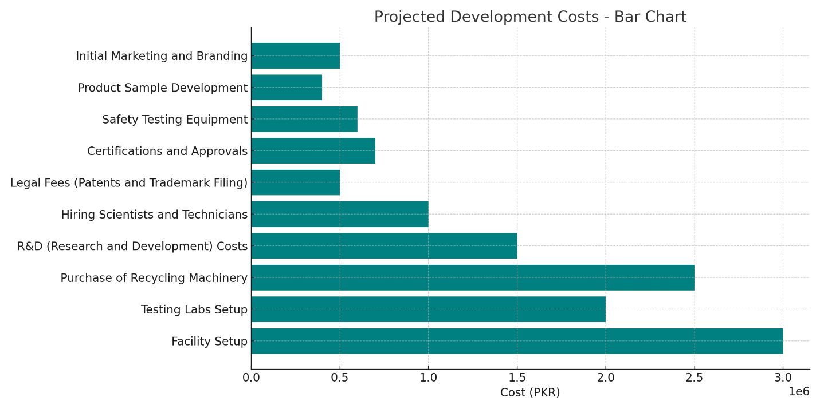

Proprietary Issues

- Patent Applications
To protect our unique recycling methods and formulations developed by our company MEDRECYCLE, we will be filing patent applications through the Intellectual Property Organization of Pakistan (IPO Pakistan).
- Trademark Protection
We will be registering our brand name MEDRECYCLE as a trademark in Pakistan to secure branding rights nationally and very soon internationally as well.
- Licensing and Certifications
Licenses and certifications will be acquired for:
- Pharmaceutical waste collection (through Health Department approvals)
- Environmental clearances from the Pakistan Environmental Protection Agency (Pak-EPA)
- Product certifications from the Pakistan Standards and Quality Control Authority (PSQCA) and testing validations by the Pakistan Council of Scientific and Industrial Research (PCSIR)

Management Team and Company Structure

Management Team

- Nimra Amer – Chief Executive Officer (CEO)

She will be responsible for overseeing all the operations of our company. Her responsibilities include making strategic decisions for the betterment of the company and leading the Research and Development (R&D) initiatives. Nimra, with her exceptional skills, will bring expertise in project management and innovation within the chemical and environmental sectors.

- Muhammad Hamza – Chief Financial Officer (CFO)

Hamza will oversee financial planning, budgeting, accounting, investor relations and securing funding. Hamza, with his strong expertise in financial management, forecasting and fundraising for sustainable startups, will be the perfect person to oversee our company’s finances.

- Muhammad Ahmad – Chief Operating Officer (COO)

Ahmad will be overseeing logistics, supply chain, production processes and day-to-day operational activities of our company. By bringing Ahmad’s expertise to the table, he will ensure the efficient manufacturing and timely distribution of our eco-friendly products.

- Muhammad Hassan Khalid – Chief Marketing Officer (CMO)

Hassan will be responsible for the marketing strategy, sales development, branding, customer engagement and market expansion efforts. His specialization in digital marketing, sustainability branding and building strategic partnerships will ensure that the public gets to know about the amazing initiative our company is offering to the world and about our eco-friendly products that we offer.

Skills Profile
The management team collectively brings critical expertise to the table, ensuring a strong foundation for the success of MEDRECYCLE’s growth. The following are the main expertise that are brought to the company by the management team:
- Chemical Engineering
Advanced knowledge in chemical recycling processes, formulation of eco-friendly products and waste treatment technologies.
- Marketing and Sales
Proven skills in strategic marketing, e-commerce management, brand positioning and B2B/B2C sales strategies.
- Financial Management
Competency in handling financial operations, managing funding pipelines, government grants, corporate social responsibility (CSR) partnerships and risk assessment.
- Sustainability and Innovation
Deep understanding of sustainable business practices, environmental compliance standards and innovative recycling methods to address pharmaceutical waste.

Future Hiring Plan
- Research and Development (R&D) Chemists
We will be hiring chemists who will enhance product innovation and perform laboratory testing. We will also be hiring people in the R&D department to optimize the recycling methods and ensure regulatory compliance for all MEDRECYCLE products.
- Sales Executives
We will be adding a sales executive to our team to drive the product distribution in retail, wholesale and export markets. His responsibility will also include focusing on developing relationships with pharmacies, hospitals, agriculture businesses and export clients.
- Operations Managers
To streamline production and reduce the burden off from the management team we will be adding an operations manager to our team that will manage the recycling and manufacturing processes, maintain inventory levels and also oversee the supply chain logistics effectively, removing the weight from the management team’s shoulder, allowing them to make more difficult decisions and generate ideas for the growth of the company.

Operation Plan

Location

The initial setup will be established in an industrial area of Lahore, Pakistan.

Reason for Selection
- Central Accessibility
Lahore's location will provide us efficient access to both urban hospitals and rural agricultural market thus making it a strategic area for MEDRECYCLE’s operations.

- Developed Infrastructure
Lahore offers strong utilities, transportation and logistics support, unlike many rural areas, making our company’s operations smoother and more reliable.

- Proximity to Key Resources
Lahore city has a high concentration of hospitals and pharmacies (for pharmaceutical waste collection) and is also surrounded by agricultural regions (for fertilizer distribution) making it a perfect choice for the setup of our company.

- Skilled Workforce
Lahore's universities and technical institutes supply qualified professionals in engineering, chemistry and business which are essential for our R&D and operations.

- Cost Efficiency
Compared to other cities, Lahore offers lower operational costs while still providing access to industrial zones, supply chains and export routes.

Facilities Needed
- Recycling and Processing Plant

  - This will be the main facility for the collection, sorting, detoxification and conversion of expired medicines into products such as fertilizers, skincare, and cleaning solutions.
  - It will be equipped with specialized chemical processing units, decontamination chambers, shredders and material recovery systems.
  - The plant will follow strict environmental compliance following the Pakistan Environmental Protection Agency (Pak-EPA) regulations.

- Research and Development (R&D) Lab

- This facility will be the area for continuous product innovation and quality assurance.
- Focus areas:
  - Testing product effectiveness and safety.
  - Developing new recycling techniques.
  - Conducting chemical analyses to ensure compliance with PSQCA (Pakistan Standards and Quality Control Authority) standards.
- Initially it will be staffed by senior chemists and lab technicians.

Packaging Unit

- It will be a dedicated area for the eco-friendly packaging of our finished products.
- Facilities for:
  - Automated and manual packing.
  - Label printing and product branding.
  - Incorporating recyclable and biodegradable materials to align with sustainability goals.

Offices for Operations and Marketing

- Administrative offices housing:
- Operations management team that will oversee the production scheduling and supply chain management.
- Sales and marketing team who will carry out product promotion, customer relationship management and market expansion.
- Finance and HR functions.
- Modern digital infrastructure with ERP (Enterprise Resource Planning) and CRM (Customer Relationship Management) systems.

Operational Highlights

Collection Process
- We will be making collaboration agreements with hospitals, pharmacies and clinics for safe collection of expired medicines.
- Deployment of specialized containers and trained collection staff.

Production Workflow

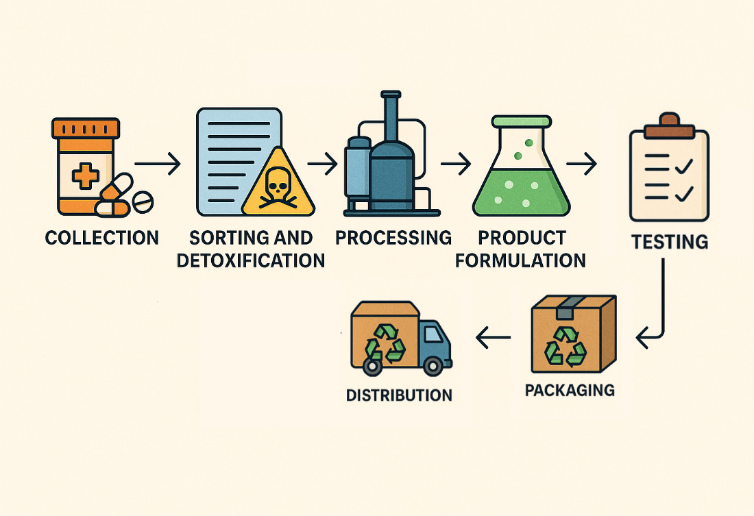

Logistics
- Partnership with local logistics companies for domestic distribution.
- Plans for export logistics setup after 18 months of operations.

Compliance and Safety
- Regular audits and inspections.
- Full compliance with National Environment Quality Standards (NEQS).
- Employee training in health, safety and environmental (HSE) practices

Financial Projections

Revenue Drivers
- Product Sales
We will be generating revenue from the sale of eco-friendly fertilizers, skincare products and household cleaners that will be developed from recycled pharmaceutical waste.
- Waste Management Service Fees
We will collect regular payments from hospitals, pharmacies and other institutions for the safe collection and recycling of expired medicines.
- Recycling Consultation and Training Services
Additional revenue from consulting businesses on waste management and conducting sustainability workshops.

Fixed Costs
- Facility Rent and Utilities
Lease expenses for recycling plant, R&D lab, packaging unit and office spaces.
- Salaries and Benefits
Fixed monthly payroll for management team, initial R&D chemists, operations staff and support staff.
- Insurance
Coverage for plant, equipment, staff health, liability and environmental safety.
- Software and Licenses
ERP (Enterprise Resource Planning), CRM (Customer Relationship Management) and compliance licenses.

Variable Costs
- Collection and Logistics Costs
Transportation, packaging for waste collection and raw material handling.
- Processing and Production Costs
Utility consumption, chemical processing, safety equipment and machine maintenance.
- Packaging and Distribution
Eco-friendly packaging material, labeling and shipment to retailers or customers.
- Marketing and Advertising
Online marketing, trade fairs, workshops and awareness campaigns.

Break-Even Analysis

Based on conservative estimates, we think MEDRECYCLE is expected to achieve break-even within 2 to 3 years of operations. The key factors contributing to early break-even will include high demand for sustainable products in the market, secured institutional contracts and multiple revenue streams (products + services).

Funding Needs

- Estimated Investment Requirement: PKR 25 million
This covers facility setup, equipment purchase, licensing, regulatory compliance, initial salaries, and marketing.
- Funding Sources
    - Founders' investment
    - Private investor funding
    - Government grants and sustainability initiatives
    - Corporate Social Responsibility (CSR) partnerships

Sales Forecast
Year | Sales (PKR) | Growth Rate
1 | 12 million (PKR) | —
2 | 13.8 million (PKR) | +15%
3 | 17.25 million (PKR) | +25%

Cash Flow Statement

Cash Flow Statement
Transaction Type | Amount (PKR)
Fertilizer Sales (Retail) | 60000
Fertilizer Sales (Wholesale) | 90000
Fertilizer Sales (Export) | 45000
Skincare Product Sales (Online) | 70000
Skincare Product Sales (Retail) | 50000
Skincare Product Sales (Wholesale) | 30000
Cleaning Product Sales (Retail) | 40000 |  | Total Inflow | 1248000
Cleaning Product Sales (Wholesale) | 30000 |  | Total OutFlow | -315000
Waste Management Service Fees | 70000 |  | GrandTotal | 933000
Recycling Consultation Services | 18000
Training Workshop Fees | 18000
Income from Product Testing Services | 22000
Equipment Leasing Income | 14000
Initial Investment by Founders | 300000
Private Investor Funding | 100000
Grants from Government Programs | 50000
Funding from Sustainability Programs | 60000
CSR Partnership Grants | 50000
Subscription Fees | 20000
Sales of R&D Licensed Products | 30000
Eco-packaging Sales | 15000
Franchise Sales | 40000
Local Contract Revenue | 26000
Salaries and Wages | -80000
Rent and Utilities | -40000
Marketing and Advertising | -30000
Insurance Payments | -5000
Office Supplies and Equipment | -10000
Research and Development Expenses | -30000
Travel and Transport Costs | -12000
Legal and Professional Fees | -8000
Accounting and Auditing Fees | -6000
Interest on Loans | -4000
Bank Charges | -3000
Debt Repayment | -15000
Inventory Purchases | -25000
Raw Material Costs | -20000
Consulting Fees | -22000
Miscellaneous Expenses | -5000

Income Statement

Income Statement
Category | Amount (PKR)
Sales of Fertilizers (Retail) | 60000
Sales of Fertilizers (Wholesale) | 90000
Sales of Fertilizers (Export) | 45000
Sales of Skincare Products (Online) | 70000
Sales of Skincare Products (Retail) | 50000 |  | Total Revenue | 757000
Sales of Skincare Products (Wholesale) | 30000 |  | Total Expences | -315000
Sales of Cleaning Products (Retail) | 40000 |  | Net Income | 442000
Sales of Cleaning Products (Wholesale) | 30000
Waste Management Service Fees | 70000
Recycling Consultation Services | 18000
Training Workshop Fees | 18000
Income from Product Testing Services | 22000
Equipment Leasing Income | 14000
Franchise Sales | 100000
Subscription Fees | 20000
Sales of R&D Licensed Products | 25000
Eco-packaging Sales | 15000
Local Contract Revenue | 40000
Salaries and Wages | -80000
Rent and Utilities | -40000
Marketing and Advertising | -30000
Insurance Payments | -5000
Office Supplies and Equipment | -10000
Research and Development Expenses | -30000
Travel and Transport Costs | -12000
Legal and Professional Fees | -8000
Accounting and Auditing Fees | -6000
Interest on Loans | -4000
Bank Charges | -3000
Debt Repayment | -15000
Inventory Purchases | -25000
Raw Material Costs | -20000
Consulting Fees | -22000
Miscellaneous Expenses | -5000

Balance Sheet

Balance Sheet
Assets | Assets Amount (PKR) | Liabilities and Equity | Liabilities Amount (PKR)
Cash and Cash Equivalents | 200000 | Founder Equity | 211900
Accounts Receivable | 50000 | Investor Equity | 100000
Prepaid Expenses | 15000 | Bank Loan | -50000
Distribution Agreements | 25000 | Grants | 40000
Consulting Contracts | 18000 | Accounts Payable | 30000
Recycling Machinery | 120000 | Accrued Expenses | 15000
Vehicles | 60000 | Deferred Revenue | 10000
Furniture and Fixtures | 20000 | Credit Line | 12000
Customer Database | 20000 | Salaries Payable | 80000
Processing Facility | 180000 | Tax Payable | 50000
R&D Lab Equipment | 90000 | Long-term Lease Obligation | 10000
Software Licenses | 15000 | Vendor Credit | 70000
Patents | 25000 | R&D Grant | 6000
Trademarks | 20000 | Equipment Lease | 8000
Website and Digital Assets | 10000 | Raw Material Credit | 7000
Marketing Collaterals | 12000 | Distribution Payable | 5000
Safety Testing Equipment | 30000 | Licensing Obligation | 4000
Product Samples | 5000 | Regulatory Fees Payable | 3000
Cloud Storage and Subscriptions | 5000 | Security Bond | 2000
Eco-friendly Packaging Inventory | 22000 | Customer Advances | 10000
Investments | 30000 | Consultant Fees Payable | 30000
Security Deposits | 10000 | Bonus Payable | 2000
Advance Payments | 8000 | Audit Fees Payable | 1500
Tools and Small Machinery | 9000 | Marketing Expenses Payable | 2500
Spare Parts Inventory | 6000 | Utility Bills Payable | 1800
Computers and Devices | 15000 | Legal Fees Payable | 1600
 |  | Employee Reimbursements | 1700
 |  | Equity Retained Earnings | 344000
 |  | Insurance Payable | 11000
Total Asserts | = | Liabilities +Equity
1020000 |  | 1020000

Overall Schedule

Milestone | Timeline
Company registration | Month 1
Facility setup | Month 2–4
Obtain regulatory approvals | Month 3–5
Launch R&D lab | Month 5
First production batch | Month 6
Launch website and e-commerce platform | Month 7
Start B2B marketing | Month 8
First sales | Month 9
Scale up production | Month 12

